Biopharmas Axed 47% More Employees Year Over Year
January 8, 2026 |
Angela Gabriel

In 2025, made or projected biopharma workforce cuts affected about 42,700 employees, according to BioSpace tallies. BioSpace takes a deep dive into which companies and locations were impacted and speaks to experts about what to expect ahead—and why.
Biopharma professionals concerned about job security likely found little comfort in 2025 as headlines about biotech and pharma layoffs stacked up and numbers climbed. Based on BioSpace tallies,* made or projected cuts last year affected about 42,700 employees, a 47.1% year-over-year increase. The number of biopharmas letting people go also went up, rising 27.6%.
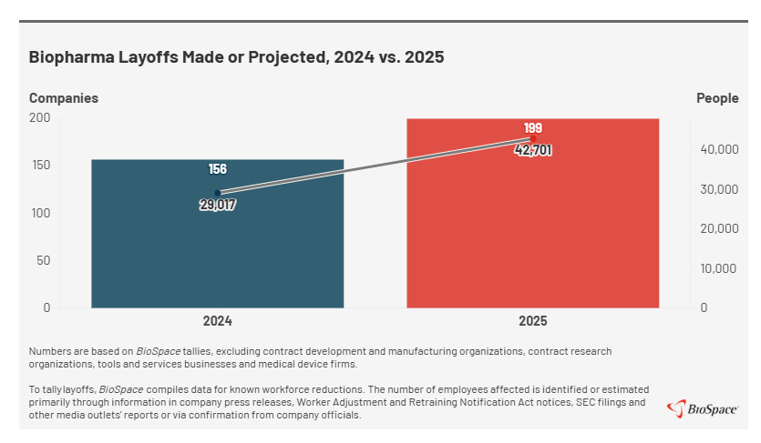
The increases didn’t surprise industry experts Eric Celidonio and Audrey Greenberg. Celidonio, founder and managing partner of biopharma recruiting firm Sci.bio Recruiting, told BioSpace in emailed responses that 2025 was a tough year for biopharma. He noted that capital tightening primarily drove the increased layoffs.
“After a wave of early-stage biotech failures, investors rotated out of the sector, which significantly constrained funding,” Celidonio said. “As capital tightened, early-stage companies had to get lean, while larger biopharma focused on acquiring late-development biotechs for core assets and key R&D talent, shedding nonessential functions where they already had scale.”
Greenberg, venture partner and chair at Mayo, told BioSpace in emailed responses that while the scale of last year’s layoffs was striking, the timing wasn’t surprising.
“By 2025, the industry reached an inflection point where delayed workforce and portfolio decisions could no longer be deferred,” she said. “Many companies were still operating with headcount and cost structures built for a capital environment that had already shifted. In 2024, there was still enough runway to postpone decisive action. In 2025, that buffer largely disappeared.”
Like Celidonio, Greenberg also pointed to capital issues—specifically “trapped capital”—as the No. 1 driver of last year’s increased layoffs.
“Investment dollars were locked inside companies that could not advance programs, access the public markets, or reach meaningful value inflection,” she said. “With the biotech IPO window effectively closed and public biotech underperforming for much of the prior cycle, pharma M&A became the only viable liquidity pathway for many assets. Companies without clear M&A appeal or near-term catalysts were forced to extend runway through workforce reductions.”
Artificial intelligence (AI) played a secondary, more indirect role in 2025’s increased layoffs, according to Greenberg. She noted that its growing adoption has begun to change how companies think about productivity and staffing. As AI tools increasingly support discovery, clinical operations, regulatory work and corporate functions, Greenberg explained, leadership teams reassess how much incremental hiring is truly necessary.
“In a capital-constrained environment, that reassessment favored leaner operating models and reduced the urgency to backfill roles, reinforcing (but not causing) the workforce reductions driven primarily by capital market dynamics,” she said.

7 Biopharmas Cutting Thousands From Workforces
In 2025, seven biopharmas announced or disclosed significant layoffs affecting at least 1,000 employees.
- Bayer cut around 4,450 people in the first three quarters based on information shared in a company media call in May and employee counts noted in second- and third-quarter earnings statements. Fourth-quarter cuts have yet to be disclosed, but during a Q3 earnings call, CEO Bill Anderson said he expected the rate of layoffs to slow moving forward.
- Bristol Meyers Squibb disclosed cuts affecting about 1,450 employees that were effective starting in 2025 and continuing into this year. Most of those layoffs are hitting the pharma’s Lawrenceville, New Jersey, workforce, including one round impacting 516 employees.
- Teva Pharmaceuticals in May announced it will let go of about 2,900 people worldwide by 2027, representing a roughly 8% reduction in force.
- Merck in July revealed it would lay off approximately 6,000 employees as part of a multiyear process. The cuts represent roughly 8% of its global workforce.
- CSL in August announced it will part ways with 15% of its employees, which could affect about 4,350 people.
- Novo Nordisk in September revealed it will cut around 9,000 employees globally.
- Novartis is reportedly letting go of about 1,069 people, with some of their end dates yet to come. In November, for example, Reuters reported the company will cut 550 full-time jobs by the end of 2027 in its home country of Switzerland.
The large cuts at Bayer, CSL, Merck and Novo Nordisk made Q3 2025’s busiest quarter for layoffs.
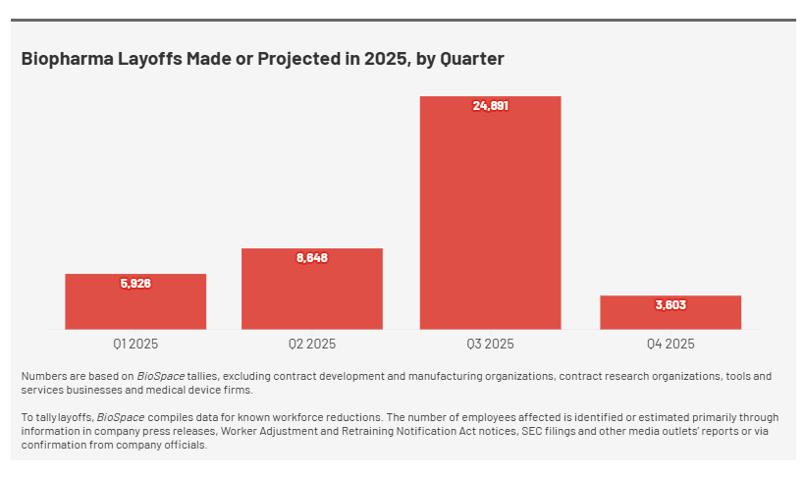
Q4 was the quietest period for workforce reductions and proved noteworthy for another reason as well. Made or projected layoffs in the fourth quarter affected 3,603, down from 6,814 year over year, a 47.1% decrease.

California, Massachusetts Hot Spots for Cuts
Not surprisingly, U.S. biopharma workforce reductions were most common in California and Massachusetts, two states known for their significant biotech and pharma presence. They had the highest number of companies making or projecting cuts: 58 in California and 56 in Massachusetts. The next-highest number in a single state was 12 in New Jersey.
California and Massachusetts also had the most cities affected by workforce reductions—22 and 11—although New Jersey finished a close third with 10.
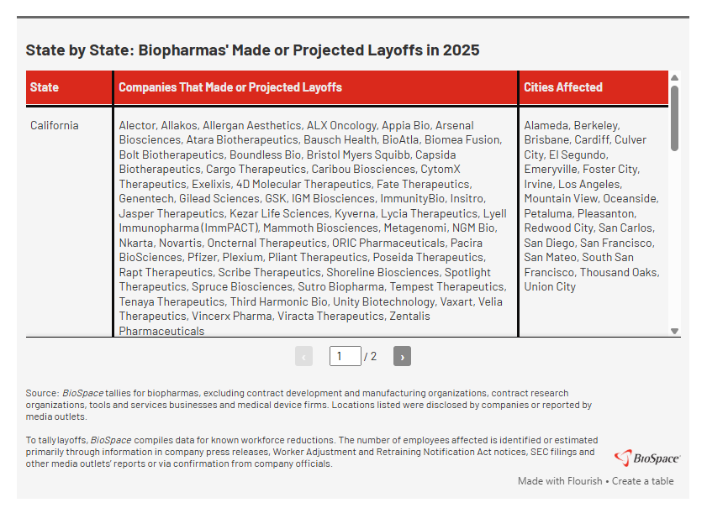
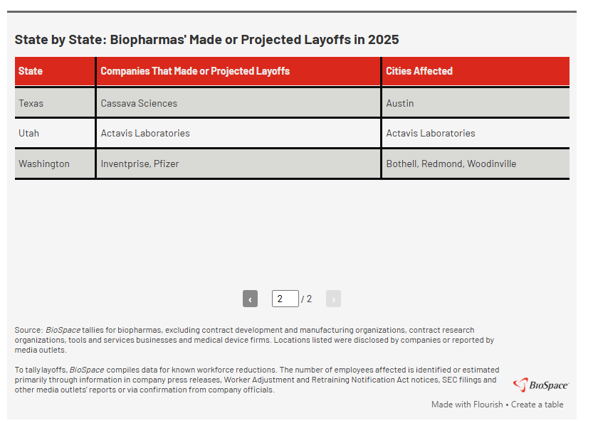
Overall, layoffs made or projected in 2025 took place in 14 states, mostly on the East Coast.
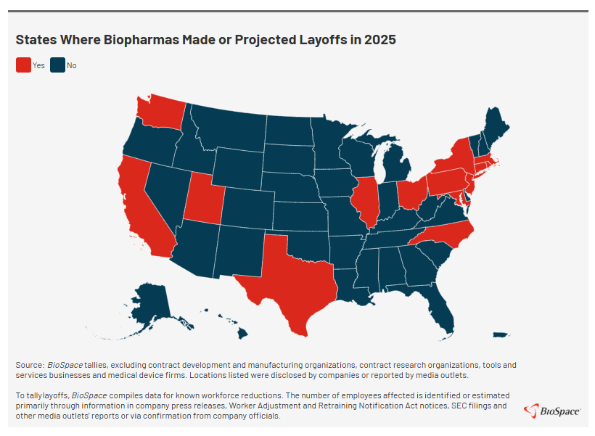

Workforce Reductions Should Slow This Year, Experts Say
Neither Celidonio nor Greenberg expect 2026’s layoffs to continue at 2025’s pace. Celidonio predicted not only a leveling off but also a modest increase in headcount.
“Rates are coming down, healthcare sentiment has improved with the XBI up over 30 percent, and a new climate of fiscal discipline combined with growth in areas like data science, AI and machine learning, and computational biology should support some improvement in 2026 in my opinion,” he said.
Greenberg echoed Celidonio’s sentiments, noting that broad-based increases in layoffs are less likely this year, as significant structural correction has already occurred and public biotech performance has begun to improve.
“As capital starts to circulate again, the pressure for indiscriminate cuts should ease,” she said. “That said, workforce changes will continue in a more targeted and strategic way, reflecting portfolio discipline and a lasting shift toward more technology-enabled operating models.”

